

***Department of computer Science and Engineering***

Assignment-1 (Documentation)

# Course code: CSE404

**Course tittle: Artificial intelligence lab Submitted by:**

## Rumman Ahmed Prodhan

Id:18101018Sec:A1.

**Submitted to:**

Molla Rashied Hussein Assistant Professor University of Asia Pacific

# Problem Statement:

Implementation of a basic family tree structure of my own family using prolog.

# Tools & Language:

Hand drawn, Prolog (Programming in Logic) functional language.

# Family Tree Structure:

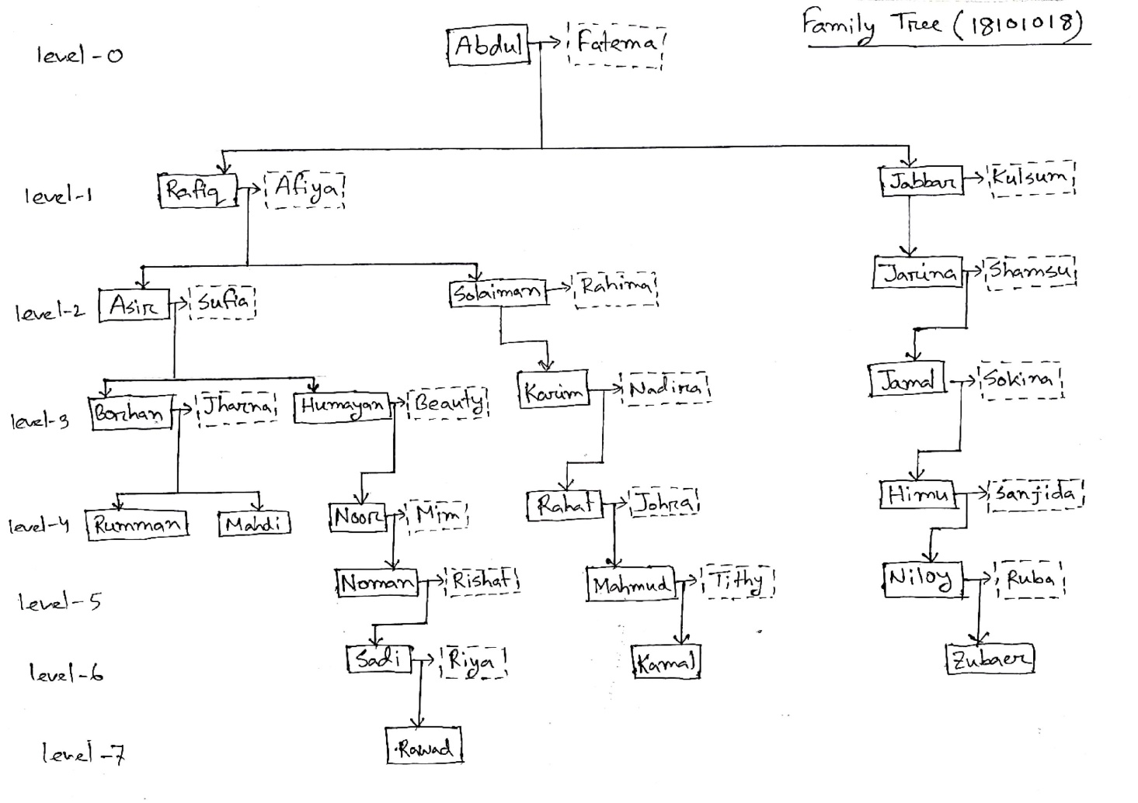

**Description:**

Above I have drawn a tree structure of my family relations. It has 8 different levels starting from level 0 to level 7. Then, I have converted this tree structure into prolog programming code with associated rules and interfaces. I have implemented some facts according to the relations from the tree as father, mother and used these facts for making the rules for the given relationships:

* Parent
* Child
* Sibling
* Grandparent
* Great-grandparent
* Great-great-grandparent
* First-cousin
* Second-cousin
* Third-cousin
* First-cousin-once removed
* Second-cousin-once removed
* Third-cousin-once removed
* First-cousin-twice removed
* Second-cousin-twice removed
* Third-cousin-twice removed

**Output:**

1. First Cousin

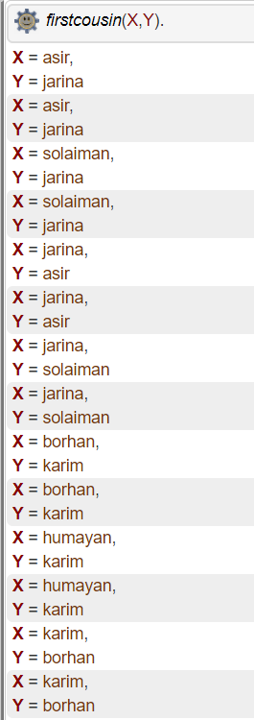

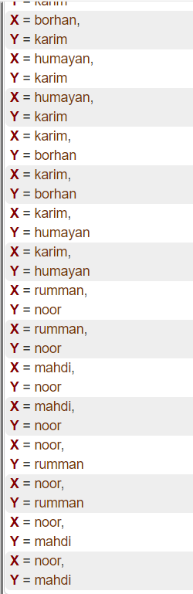

1. First Cousin Once Removed

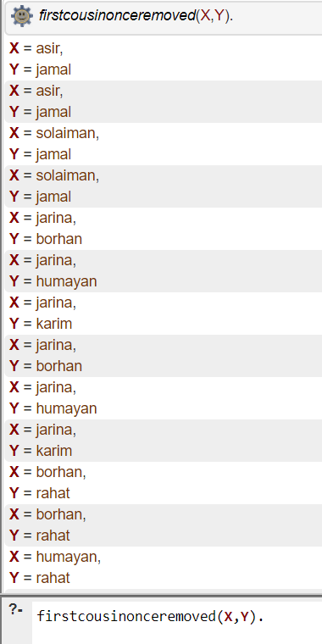

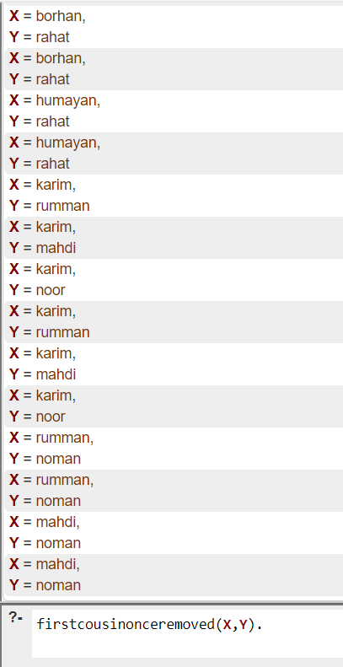

1. First Cousin Twice Removed

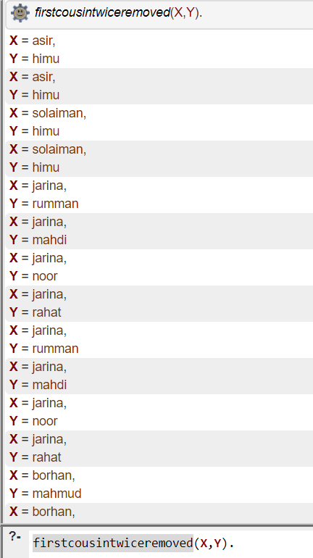

1. Second Cousin

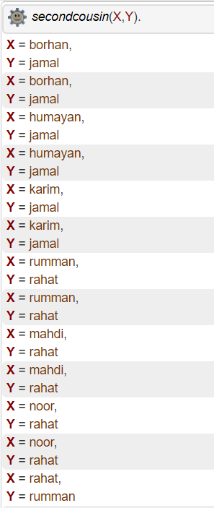

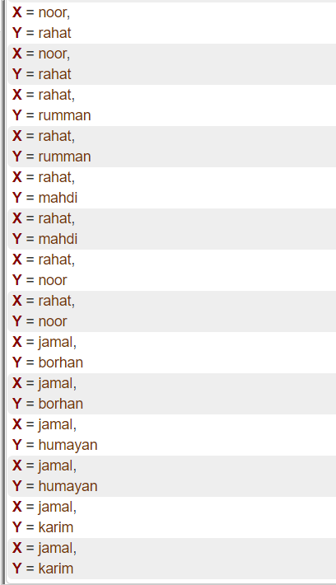

1. Second Cousin Once Removed

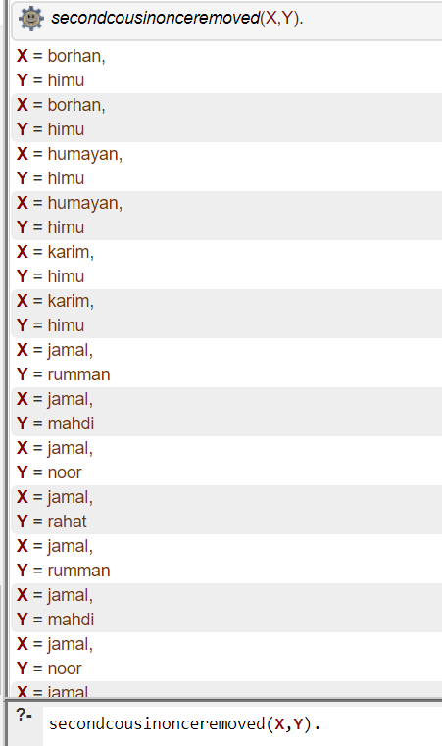

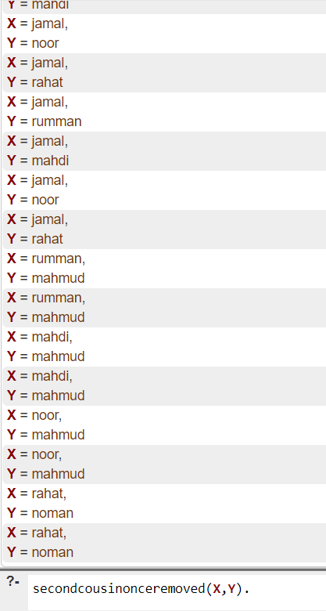

1. Second Cousin Twice Removed

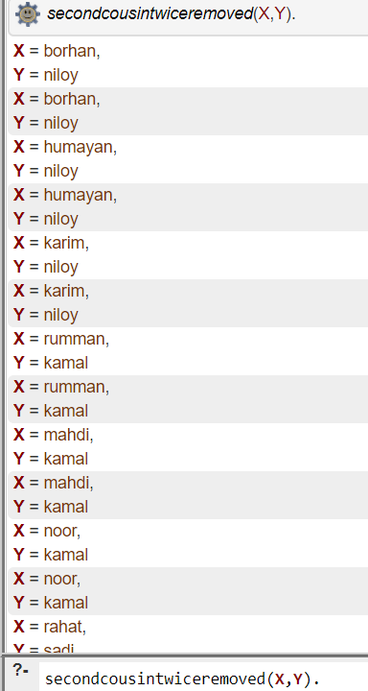

1. Third Cousin

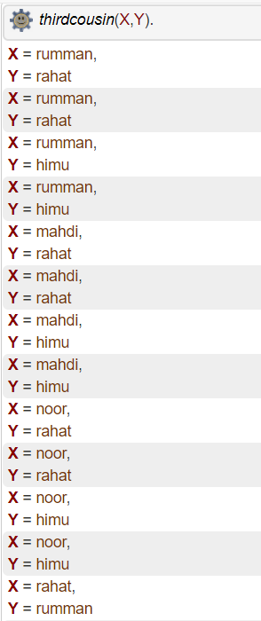

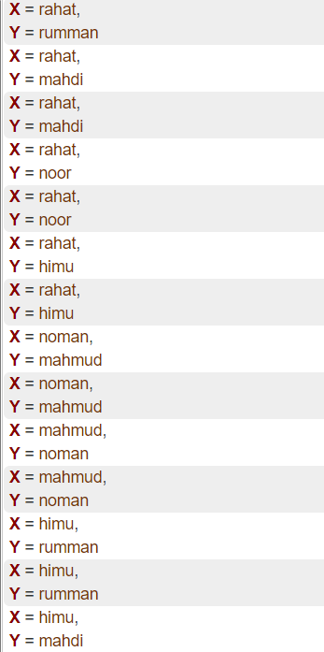

1. Third Cousin Once Removed

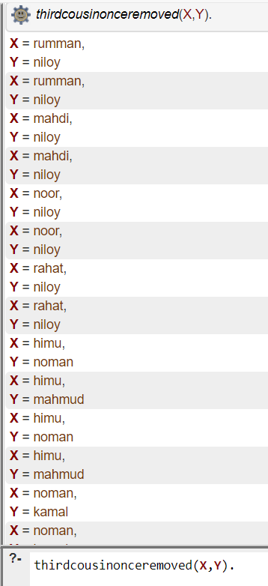

1. Third Cousin Twice Removed

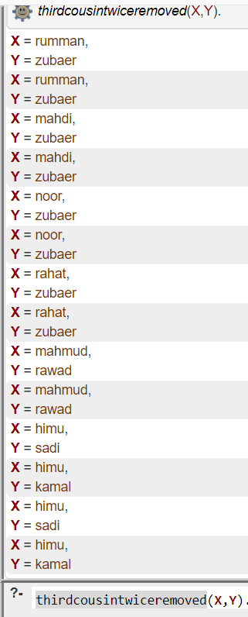

**Conclusion:**

While implementing this tree structure in prolog I had to face some challenges. For example, while implementing the rules for third cousin I had to make sure that the two of the characters who are third cousin, their parent and Grandparent isn’t similar. If they are similar then they can be siblings or first cousin but not third cousin. So, I had to use these two rules there:

not(M=@=N),

not(P=@=Q).

By overcoming these kinds of challenges, I did able to implement the relationships between the members of my family tree structure